Record No: 0626
WILLIAM DENNISTOUN SOMERVILLE (Uncle Billy)

Eldest son of Tenison Alan Somerville (0591) and Cecilia Eliza O’Connor (0592).

Birth: 8 Jun 1842, Naparihia, Trinidad, West Indies
Baptism: 6 Sept 1842, St Paul’s, San Fernando, Trinidad
Death: 10 Mar 1917, Bloomfield, Morehampton Rd, Donnybrook,Dublin
Burial: Mt Jerome Cemetary, Dublin

unmarried

:

Source: Somerville Index.

Notes: Owing to a medical accident when a child in Trinidad, Uncle Billy was dumb throughout his life. Following his parents’ death, he lived at Clermont with his brother, Bellingham Arthur(0631), and his wife, Margaret Hall(0632), until the death of the former in 1916, when he moved to Bloomfield, the long established nursing home in Donnybrook, near his brother, Henry Bellingham(0628 ),who lived at 74,Morehampton Road, Donnybrook.

Some members of the family suffer from a slight impediment of speech, notably, in the lifetime of WBRBS, Regi(0670) and Tetty(0680 ); nothing was done to correct this, presumably because of the accident in Trinidad, when the doctor ‘cut the wrong string’ below Uncle Billy’s tongue, according to Regi.

Attached below is a copy of a photograph showing Uncle Billy, sitting in the dining room at Clermont, in front of the double doors leading to the study. Above the doors is a pencil drawing of his father Tenison Alan(0591) and to the viewers left is a painting of Rivers Abbey in Yorkshire painted by Margaret Hall Clinch(0632 ) in her youth. Both are now in the possession of WBRBS.

Source: WBRBS
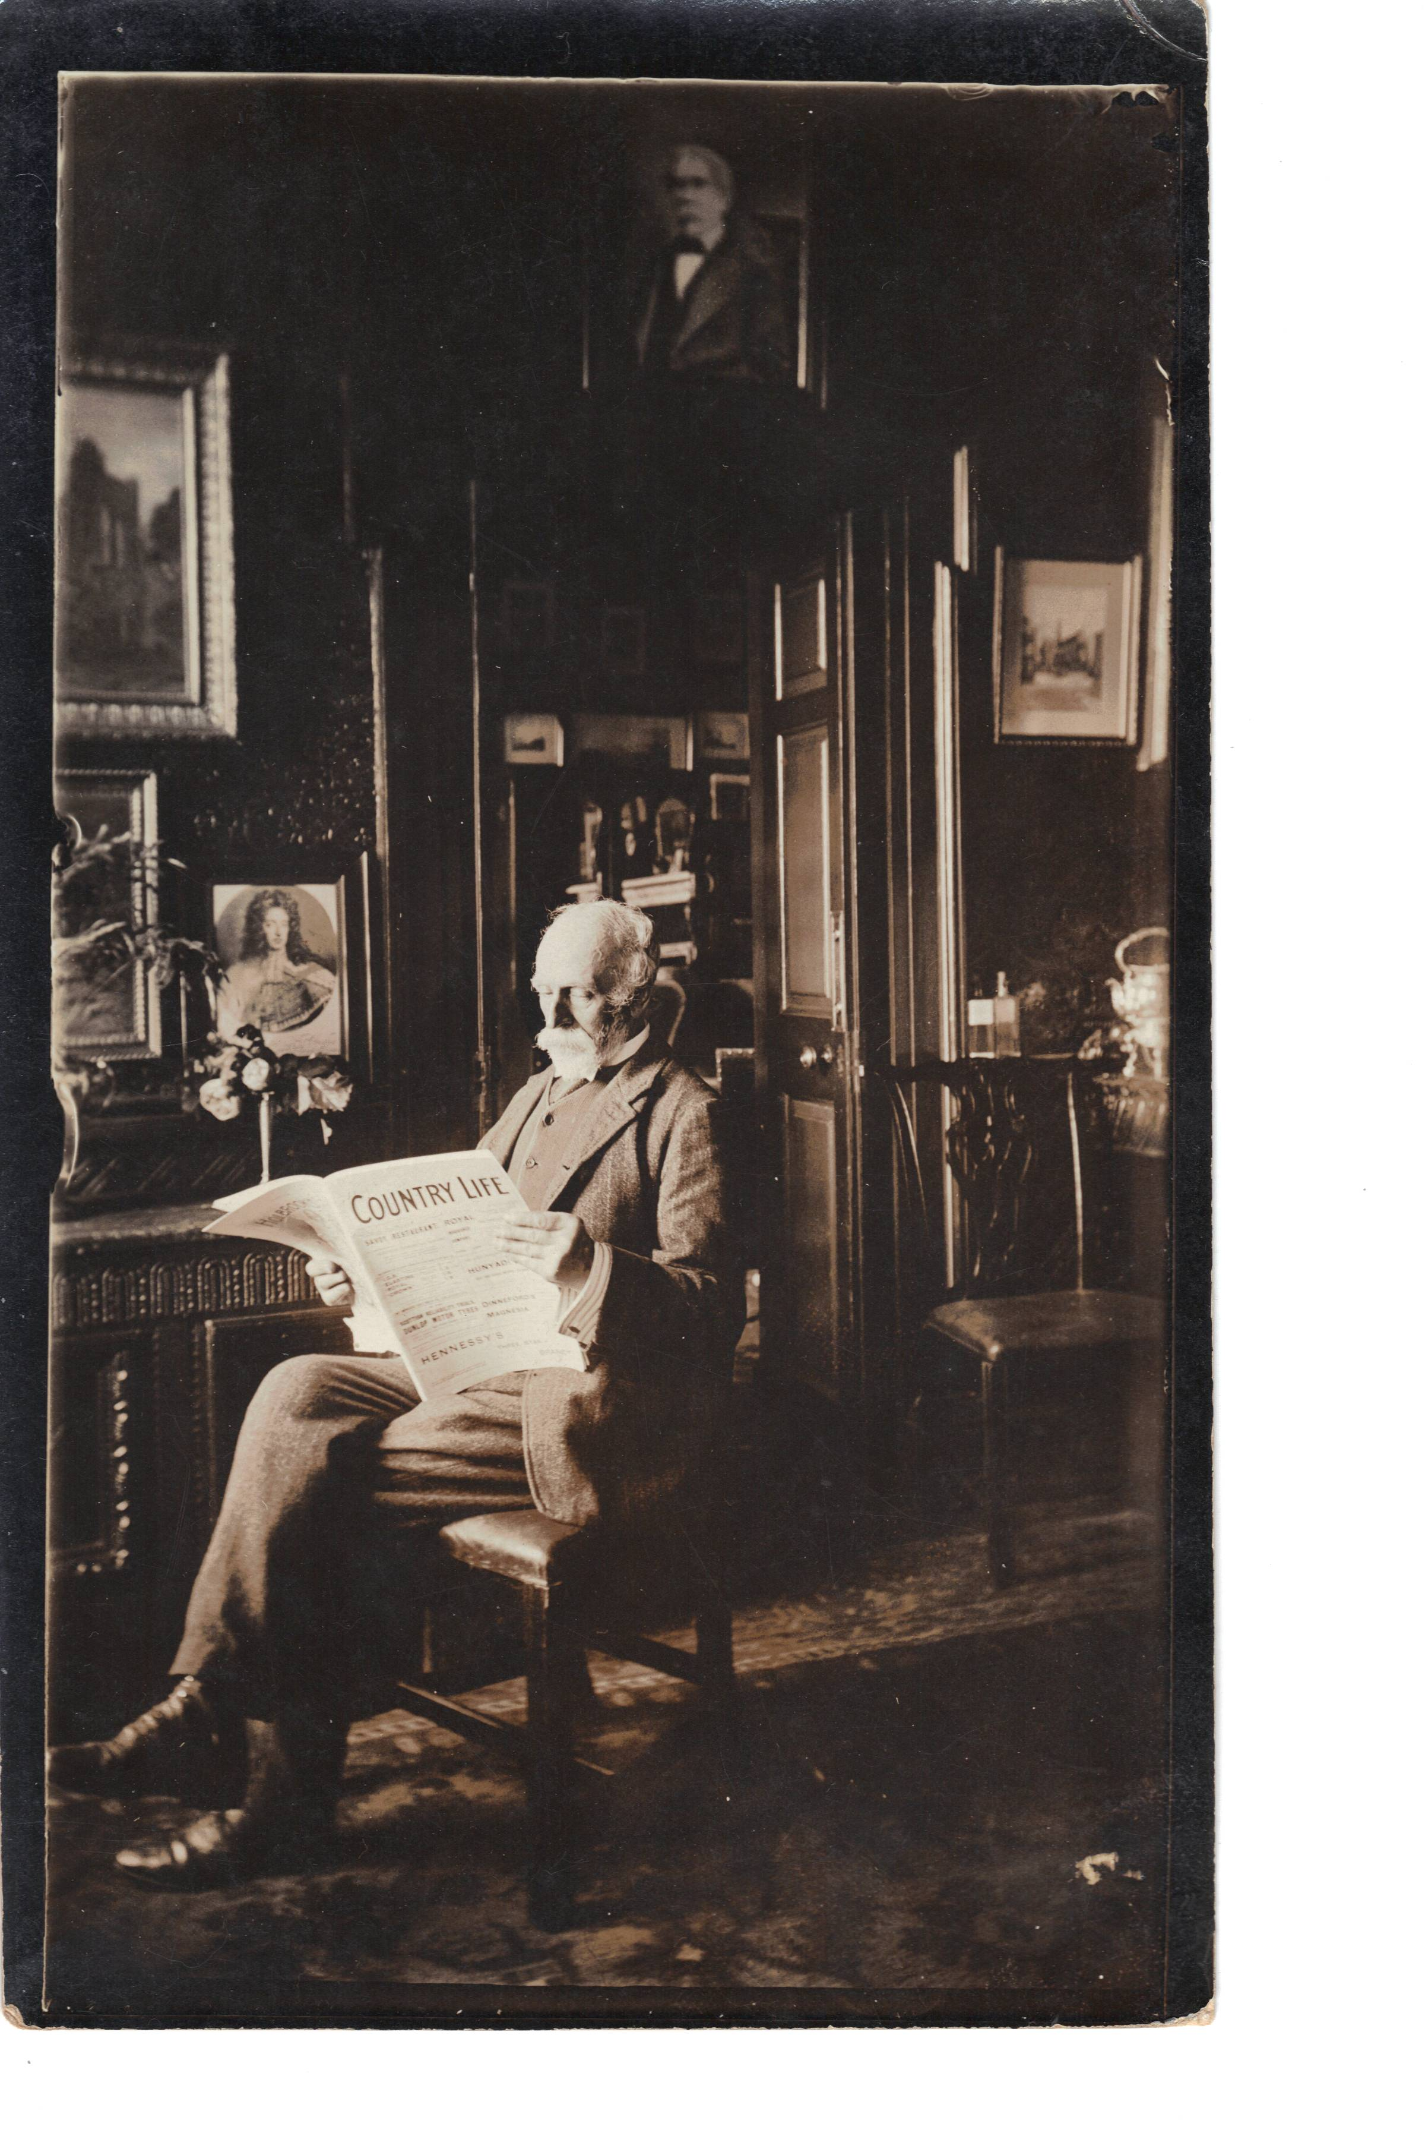
Uncle Billy’William Dennistown Somerville, son of Tenison Alan Somerville and Cecilia O’Connor
(1842-1917)

